**Emergency Responder Radio System**

**Coverage Report Test Results**

**\*\*\*Table 1\*\*\***

|  |  |
| --- | --- |
| **Date Prepared:** | Mar 13, 2025 |
| **Test File:** | SEA 2025 Garage1 |
| **Test Location:** | SEA Garage (CC) |
|  |  |
| **Technician:** | Aaron Keyte |
| **FCC#:** | PG00066071 |

**Building: SEA Garage (CC)**

**Result: Fail (Adjacent Area Rule)**

**\*\*\*Table 2\*\*\***

**Test Report Summary**

| **Channel/ Ch Group** | **Freq (MHz)** | **Technology** | **Band** | **Result** | **Area Points**  **passed (%)** | **Critical Points passed (%)** |
| --- | --- | --- | --- | --- | --- | --- |
| 1 | 852.38750 | P25 | SeaTac 2025 | Fail (Adjacent) | 510/555 (91%) | 81/88 (92%) |

**\*\*\*Table 3\*\*\***

|  |  |  |  |
| --- | --- | --- | --- |
| **Test Details** | | | |
| **Number of Floors Tested:** | 5 | **Result Calculation:** | By area per floor |
| **Number of Areas Tested:** | 555 | **Area Pass Criteria:** | 95% |
| **Number of Critical Points Tested:** | 88 | **Critical Points Pass Criteria:** | 99% |
|  |  | **Apply Adjacent Area Rule:** | Yes |

**\*\*\*Table 4\*\*\***

|  |  |  |  |  |
| --- | --- | --- | --- | --- |
| **Equipment Configuration** | | | | |
| **Vendor** | **Application** | **Device** | **Calibration Expires** | **Antenna info** |
| PCTEL | SeeHawk Touch  rel 3.2.0.2 | SeeGull IBflex Device rel 3.10.0.0  SN: 081911044 | 2-13-2026 | Ant1:Motorola V/U/700/800 |
| Motorola | NA | Portable Radio: APX-6000 | NA | MODEL: H98UCF9PW6BN  SN: 481CWF73200 |
| Motorola | NA | Portable Radio: APX-6000 | NA | MODEL: H98UCF9PW6BN  SN: 481CWF73200 |

**\*\*\*Table 5\*\*\***

**Threshold Settings**

| **Measurement** | **DL Area Point** | **UL Area Point** | **DL Critical Point** | **UL Critical Point** | **Use for grading** |
| --- | --- | --- | --- | --- | --- |
| P25 Power (RSSI) | -95.0 dBm | -95.0 dBm | -95.0 dBm | -95.0 dBm | Yes |
| P25 S/N (SINR) | 16.0 dB | 16.0 dB | 16.0 dB | 16.0 dB | Yes |
| P25 FBER | 2.6 % | 2.6 % | 2.6 % | 2.6 % | Yes |
| DAQ | 3.4 |  |  |  | Yes |

**\*\*\*Table 6\*\*\***

**Floors Result**

| **Floor Plan** | **1 852.38750** |
| --- | --- |
| Garage L1 | **Fail (Adjacent)** |
| Garage L2 | **Fail (Adjacent)** |
| Garage L3 | **Pass** |
| Garage L4 | **Pass** |
| Garage L5 | **Pass** |

**Floor: Garage L1**

**Channel: 1**

**Result: Fail (Adjacent)**

**\*\*\*Table 7\*\*\***

| **Freq (MHz)** | **Tech** | **Band** | **Ant Gain** | **Cable Loss** | **Ph.** | **Type** | **Mod** | **NAC** | **Area Points passed (%)** | **Critical Points passed (%)** |
| --- | --- | --- | --- | --- | --- | --- | --- | --- | --- | --- |
| 852.38750 | P25 | SeaTac 2025 | 0.00 | 0.00 | 1 | TC | CQPSK | 67A | 80/113 (70%) | 11/16 (68%) |

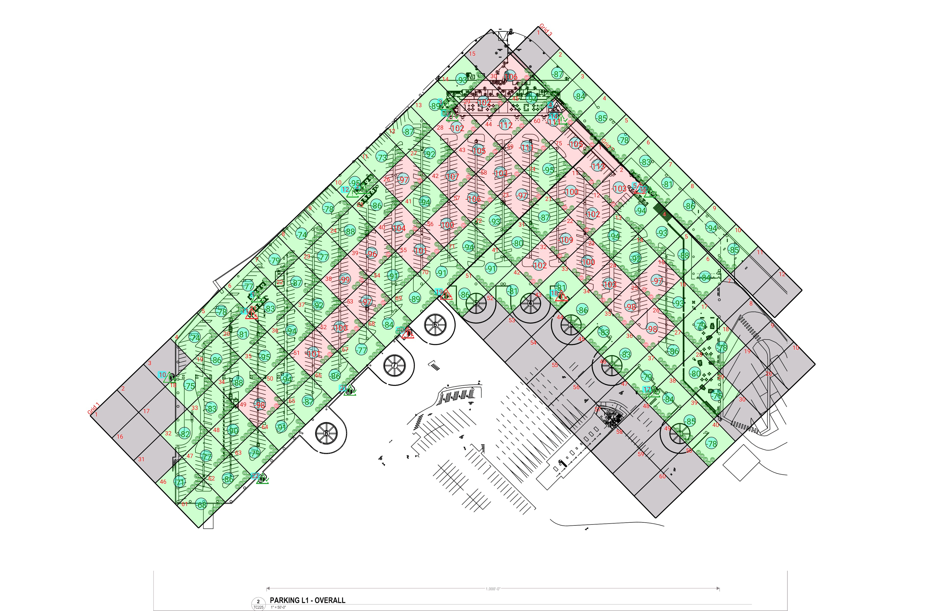

**\*\*\*Table 8\*\*\***

| **Grid** | **# of Areas** | **Area Size (sq. ft)** | **Area Width**  **(ft)** | **Area Height**  **(ft)** | **Ignore Area Color** | **Comments** |
| --- | --- | --- | --- | --- | --- | --- |
| 1 | 75 | 5690.19 | 82.14 | 69.28 | Black |  |
| 2 | 60 | 5628.18 | 68.58 | 82.07 | Black |  |
| 3 | 12 | 5958.26 | 68.81 | 86.59 | Black |  |

**Floor: Garage L1**

**Channel: 1**

**\*\*\*Table 9\*\*\***

| **Critical Point Report** | | | | | | | | | | | |
| --- | --- | --- | --- | --- | --- | --- | --- | --- | --- | --- | --- |
| **Critical Point** | **DL**  **Power**  **(dBm)** | **DL**  **S/N**  **(dB)** | **DL FBER (%)** | **DL**  **DAQ** | **UL**  **Power**  **(dBm)** | **UL**  **S/N**  **(dB)** | **UL FBER (%)** | **UL**  **DAQ** | **Result** | **DL**  **Loss**  **(dB)** | **Comment** |
| 1 | -86.50 | 34.36 | 0.00 | 5.0 |  |  |  | 5.0 | **Pass** |  |  |
| 2 | -84.82 | 34.76 | 0.00 | 5.0 |  |  |  | 5.0 | **Pass** |  |  |
| 3 | -88.91 | 34.45 | 0.56 | 5.0 |  |  |  | 5.0 | **Pass** |  |  |
| 4 |  |  |  |  |  |  |  |  |  |  | No Access |
| 5 | -100.54 | 26.93 | 0.00 | 5.0 |  |  |  | 5.0 | **Fail** |  |  |
| 10 | -79.60 | 35.44 | 0.00 | 5.0 |  |  |  | 5.0 | **Pass** |  |  |
| 11 | -104.71 | 24.25 | 2.03 | 5.0 |  |  |  | 5.0 | **Fail** |  |  |
| 12 | -92.05 | 33.68 | 0.00 | 5.0 |  |  |  | 5.0 | **Pass** |  |  |
| 13 | -85.66 | 35.23 | 0.00 | 5.0 |  |  |  | 5.0 | **Pass** |  |  |
| 14 | -87.57 | 35.13 | 0.00 | 5.0 |  |  |  | 5.0 | **Pass** |  |  |
| 15 | -91.75 | 34.02 | 0.00 | 5.0 |  |  |  | 5.0 | **Pass** |  |  |
| 17 | -84.39 | 35.41 | 0.00 | 5.0 |  |  |  | 5.0 | **Pass** |  |  |
| 18 | -86.54 | -35.11 | 0.00 | 5.0 |  |  |  | 5.0 | **Fail** |  |  |
| 19 | -81.77 | -35.58 | 0.00 | 5.0 |  |  |  | 5.0 | **Fail** |  |  |
| 20 | -96.52 | 27.01 | 1.67 | 5.0 |  |  |  | 5.0 | **Fail** |  |  |
| 21 | -78.94 | 36.03 | 0.00 | 5.0 |  |  |  | 5.0 | **Pass** |  |  |
| 22 | -86.65 | 29.44 | 0.00 | 5.0 |  |  |  | 5.0 | **Pass** |  |  |

**\*\*\*Table 10\*\*\***

| **Area Report** | | | | | | | | | | | | |
| --- | --- | --- | --- | --- | --- | --- | --- | --- | --- | --- | --- | --- |
| **Grid** | **Area** | **DL**  **Power**  **(dBm)** | **DL**  **S/N**  **(dB)** | **DL FBER (%)** | **DL**  **DAQ** | **UL**  **Power**  **(dBm)** | **UL**  **S/N**  **(dB)** | **UL FBER (%)** | **UL**  **DAQ** | **Result** | **DL**  **Loss**  **(dB)** | **Comment** |
| 1 | 1 | NT | NT | NT | NT | NT | NT | NT | NT | **NT** |  |  |
| 1 | 2 | NT | NT | NT | NT | NT | NT | NT | NT | **NT** |  |  |
| 1 | 3 | NT | NT | NT | NT | NT | NT | NT | NT | **NT** |  |  |
| 1 | 4 | -73.95 | 35.67 | 0.00 | 5.0 |  |  |  | 5.0 | **Pass** |  |  |
| 1 | 5 | -77.67 | 35.35 | 0.00 | 5.0 |  |  |  | 5.0 | **Pass** |  |  |
| 1 | 6 | -76.32 | 36.38 | 0.00 | 5.0 |  |  |  | 5.0 | **Pass** |  |  |
| 1 | 7 | -78.34 | 36.42 | 0.00 | 5.0 |  |  |  | 5.0 | **Pass** |  |  |
| 1 | 8 | -73.31 | 36.19 | 0.00 | 5.0 |  |  |  | 5.0 | **Pass** |  |  |
| 1 | 9 | -77.38 | 36.11 | 0.00 | 5.0 |  |  |  | 5.0 | **Pass** |  |  |
| 1 | 10 | -94.70 | 32.62 | 0.00 | 5.0 |  |  |  | 5.0 | **Pass** |  |  |
| 1 | 11 | -72.30 | 35.05 | 0.00 | 5.0 |  |  |  | 5.0 | **Pass** |  |  |
| 1 | 12 | -86.19 | 34.46 | 0.00 | 5.0 |  |  |  | 5.0 | **Pass** |  |  |
| 1 | 13 | -88.40 | 34.98 | 0.00 | 5.0 |  |  |  | 5.0 | **Pass** |  |  |
| 1 | 14 | -92.86 | 33.61 | 0.00 | 5.0 |  |  |  | 5.0 | **Pass** |  |  |
| 1 | 15 | NT | NT | NT | NT | NT | NT | NT | NT | **NT** |  |  |
| 1 | 16 | NT | NT | NT | NT | NT | NT | NT | NT | **NT** |  |  |
| 1 | 17 | NT | NT | NT | NT | NT | NT | NT | NT | **NT** |  |  |
| 1 | 18 | -74.97 | 35.69 | 0.00 | 5.0 |  |  |  | 5.0 | **Pass** |  |  |
| 1 | 19 | -85.48 | 35.45 | 0.00 | 5.0 |  |  |  | 5.0 | **Pass** |  |  |
| 1 | 20 | -80.91 | 35.34 | 0.00 | 5.0 |  |  |  | 5.0 | **Pass** |  |  |
| 1 | 21 | -82.98 | 35.83 | 0.00 | 5.0 |  |  |  | 5.0 | **Pass** |  |  |
| 1 | 22 | -86.10 | 35.15 | 0.00 | 5.0 |  |  |  | 5.0 | **Pass** |  |  |
| 1 | 23 | -76.93 | 31.58 | 0.00 | 5.0 |  |  |  | 5.0 | **Pass** |  |  |
| 1 | 24 | -87.72 | 34.71 | 0.00 | 5.0 |  |  |  | 5.0 | **Pass** |  |  |
| 1 | 25 | -85.30 | 34.85 | 0.00 | 5.0 |  |  |  | 5.0 | **Pass** |  |  |
| 1 | 26 | -96.80 | 31.18 | 0.00 | 5.0 |  |  |  | 5.0 | **Fail** |  |  |
| 1 | 27 | -91.70 | 34.13 | 0.00 | 5.0 |  |  |  | 5.0 | **Pass** |  |  |
| 1 | 28 | -101.85 | 27.55 | 0.00 | 5.0 |  |  |  | 5.0 | **Fail** |  |  |
| 1 | 29 | -101.27 | 27.88 | 0.00 | 5.0 |  |  |  | 5.0 | **Fail** |  |  |
| 1 | 30 | -105.58 | 23.46 | 0.00 | 5.0 |  |  |  | 5.0 | **Fail** |  |  |
| 1 | 31 | NT | NT | NT | NT | NT | NT | NT | NT | **NT** |  |  |
| 1 | 32 | -81.69 | 35.52 | 0.00 | 5.0 |  |  |  | 5.0 | **Pass** |  |  |
| 1 | 33 | -82.32 | 35.60 | 0.00 | 5.0 |  |  |  | 5.0 | **Pass** |  |  |
| 1 | 34 | -87.17 | 31.35 | 0.00 | 5.0 |  |  |  | 5.0 | **Pass** |  |  |
| 1 | 35 | -94.43 | 32.43 | 0.65 | 5.0 |  |  |  | 5.0 | **Pass** |  |  |
| 1 | 36 | -93.56 | 33.02 | 0.00 | 5.0 |  |  |  | 5.0 | **Pass** |  |  |
| 1 | 37 | -91.84 | 29.15 | 0.00 | 5.0 |  |  |  | 5.0 | **Pass** |  |  |
| 1 | 38 | -98.02 | 30.34 | 0.00 | 5.0 |  |  |  | 5.0 | **Fail** |  |  |
| 1 | 39 | -95.50 | 29.56 | 0.00 | 5.0 |  |  |  | 5.0 | **Fail** |  |  |
| 1 | 40 | -103.25 | 24.20 | 0.00 | 5.0 |  |  |  | 5.0 | **Fail** |  |  |
| 1 | 41 | -93.10 | 33.02 | 0.90 | 5.0 |  |  |  | 5.0 | **Pass** |  |  |
| 1 | 42 | -106.04 | 23.54 | 0.00 | 5.0 |  |  |  | 5.0 | **Fail** |  |  |
| 1 | 43 | -104.92 | 24.36 | 0.00 | 5.0 |  |  |  | 5.0 | **Fail** |  |  |
| 1 | 44 | -111.86 | 18.25 | 0.00 | 5.0 |  |  |  | 5.0 | **Fail** |  |  |
| 1 | 45 | -93.51 | 32.89 | 0.00 | 5.0 |  |  |  | 5.0 | **Pass** |  |  |
| 1 | 46 | -70.19 | 36.11 | 0.00 | 5.0 |  |  |  | 5.0 | **Pass** |  |  |
| 1 | 47 | -76.23 | 35.56 | 0.00 | 5.0 |  |  |  | 5.0 | **Pass** |  |  |
| 1 | 48 | -89.08 | 34.49 | 0.00 | 5.0 |  |  |  | 5.0 | **Pass** |  |  |
| 1 | 49 | -97.75 | 30.67 | 0.62 | 5.0 |  |  |  | 5.0 | **Fail** |  |  |
| 1 | 50 | -93.13 | 32.70 | 0.00 | 5.0 |  |  |  | 5.0 | **Pass** |  |  |
| 1 | 51 | -100.47 | 28.98 | 0.00 | 5.0 |  |  |  | 5.0 | **Fail** |  |  |
| 1 | 52 | -99.14 | 29.38 | 0.00 | 5.0 |  |  |  | 5.0 | **Fail** |  |  |
| 1 | 53 | -96.63 | 31.65 | 0.00 | 5.0 |  |  |  | 5.0 | **Fail** |  |  |
| 1 | 54 | -90.41 | 34.48 | 0.00 | 5.0 |  |  |  | 5.0 | **Pass** |  |  |
| 1 | 55 | -100.83 | 27.41 | 0.00 | 4.0 |  |  |  | 4.0 | **Fail** |  |  |
| 1 | 56 | -99.54 | 29.27 | 0.00 | 5.0 |  |  |  | 5.0 | **Fail** |  |  |
| 1 | 57 | -105.53 | 24.14 | 0.00 | 5.0 |  |  |  | 5.0 | **Fail** |  |  |
| 1 | 58 | -102.34 | 26.80 | 0.00 | 5.0 |  |  |  | 5.0 | **Fail** |  |  |
| 1 | 59 | -110.34 | 20.75 | 1.13 | 5.0 |  |  |  | 5.0 | **Fail** |  |  |
| 1 | 60 | -110.31 | 19.31 | 0.60 | 5.0 |  |  |  | 5.0 | **Fail** |  |  |
| 1 | 61 | -67.20 | 36.17 | 0.00 | 5.0 |  |  |  | 5.0 | **Pass** |  |  |
| 1 | 62 | -85.06 | 34.85 | 0.00 | 5.0 |  |  |  | 5.0 | **Pass** |  |  |
| 1 | 63 | -78.29 | 35.96 | 0.00 | 5.0 |  |  |  | 5.0 | **Pass** |  |  |
| 1 | 64 | -90.22 | 34.37 | 0.00 | 5.0 |  |  |  | 5.0 | **Pass** |  |  |
| 1 | 65 | -86.46 | 35.55 | 0.00 | 5.0 |  |  |  | 5.0 | **Pass** |  |  |
| 1 | 66 | -86.00 | 34.96 | 0.00 | 5.0 |  |  |  | 5.0 | **Pass** |  |  |
| 1 | 67 | -76.65 | 35.67 | 0.00 | 5.0 |  |  |  | 5.0 | **Pass** |  |  |
| 1 | 68 | -83.03 | 35.49 | 0.00 | 5.0 |  |  |  | 5.0 | **Pass** |  |  |
| 1 | 69 | -88.23 | 34.98 | 0.00 | 5.0 |  |  |  | 5.0 | **Pass** |  |  |
| 1 | 70 | -91.00 | 33.94 | 0.00 | 5.0 |  |  |  | 5.0 | **Pass** |  |  |
| 1 | 71 | -93.10 | 33.26 | 0.00 | 5.0 |  |  |  | 5.0 | **Pass** |  |  |
| 1 | 72 | -92.50 | 33.09 | 0.64 | 5.0 |  |  |  | 5.0 | **Pass** |  |  |
| 1 | 73 | -96.78 | 30.98 | 0.00 | 5.0 |  |  |  | 5.0 | **Fail** |  |  |
| 1 | 74 | -94.22 | 31.92 | 0.00 | 5.0 |  |  |  | 5.0 | **Pass** |  |  |
| 1 | 75 | -104.63 | 24.91 | 0.00 | 5.0 |  |  |  | 5.0 | **Fail** |  |  |

**Additional Info**